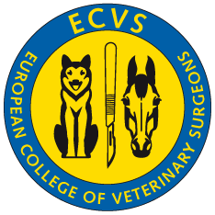
European College of Veterinary Surgeons

c/o Vetsuisse Faculty University of Zurich, Equine Department / Winterthurerstrasse 260, CH-8057 Zurich, Switzerland Phone: +41 (0)44 635 84 92 / 90 / Fax: +41 (0)44 635 89 91 / email: credentials@ecvs.org / web: www.ecvs.org

Name & address of ACVS Diplomate

Date:

ACVS Diplomate Application Fee

Please note: you may transfer the amount in EURO directly to our bank account mentioned below! Visa- and MasterCard charges can be effected in Euros; American Express only in CHF.

ACVS Diplomate applying for ECVS Diplomate status | € | 100.–

Please return the completed and signed form either by mail or fax to the ECVS office

Cheque enclosed Transfer to bank account €
(please make sure all bank charges and commissions are covered!)
Charge to VISA MasterCard American Express

Credit card number:
Card Expires: / Security code
(three last digits in signature field)

Card holder’s name and signature:

The payment form is to be sent to the ECVS Office along with the complete application documents.

Bank information for direct bank transfers:
Union Bank of Switzerland (UBS), CH - 8050 Zurich-Oerlikon

payment in Euro (€)
European College of Veterinary Surgeons IBAN N°: CH07 0026 9269 8001 3802 M SWIFT/BIC: UBSWCHZH80A

