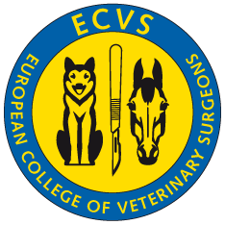
ECVS – Supervisors statement

to accompany report of _________________ [dd.mm.yy]

for Standard VRSP Dual-site Standard VRSP Alternate VSTP

Tick the correct box

A copy of this statement must accompany each of the Residents reports to ECVS.

Name of Resident
Date of entry to Training Programme
Planned year of qualifying examination
Name of Supervisor
Institution of Supervisor
Names of other resident(s) supervised by supervisor
Co-supervisor (in case of Dual-site Standard VRSP)
Institution of Co-Supervisor (in case of Dual-site Standard VRSP)
Names of other resident(s) supervised by co-supervisor
For LA programme: Surgical caseload in institution last year

In case of dual-site Standard VRSP the form below needs to be filled out by the supervisor

Progression of the trainee's clinical training and development

Describe how the trainee progressed professionally in the last year (max. 100 words)

Assessment of progress on manuscripts, research, continuing education/training (max. 100 words):

Are there any reservations about the residents clinical, professional and ethical progress to date in their training programme? No Yes
If yes please provide details below:
In your opinion, will this resident complete their credentials submission on time i.e. for the planned year of qualifying examination? Yes No
If no, please provide details below:

Verification of ECVS programme facilities, staff, services and equipment
I verify that the personnel, facilities, service and equipment for the Standard VSRP / Alternate VSTP are present and available to the Resident and that they, along with the programme itself, are in accordance with current ECVS requirements and have not changed since the last report.

I remain active in the practice of veterinary surgery and continue to satisfy the requirements as a Supervisor.

Date [dd.mm.yy] _____________

Supervisors’ signature (Dipl ECVS) __________________________________________

